PEOPLE WHO SHINE A LIGHT ON FUTURE GENERATIONS
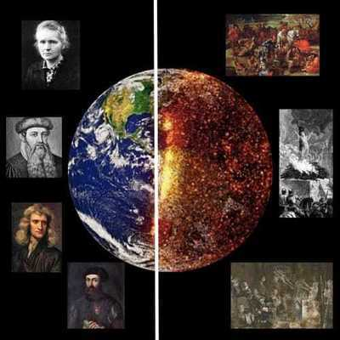
This project involves pupils creating original biographies by researching the lives of scientists. While doing their research, pupils will both learn the life stories of scientists and better understand their contributions to our ongoing lives.
First of all, each pupil will choose a different scientist who has contributed to the world of science. They will research the person they have chosen in detail and create their biographies. Then each pupil will create a poster with Canva to display on school board using visual contents. Each pupil will create a dialogue about the biographies prepared both by forming groups of two or three and using ICT collaborative tools.
At the end, students will create an audiobook in Storyjumper by converting the biographies into autobiographies.

