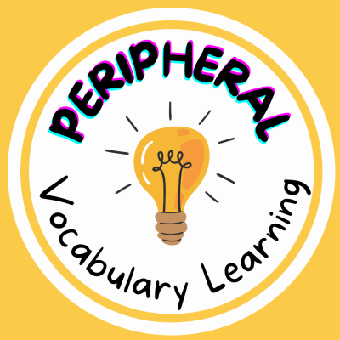
PROJECT●
Active

Peripheral Vocabulary Learning in the Classroom V2
A project to experience a peripheral learning for vocabulary through a coloring book, a poem, a drama, puppets and informative videos.

