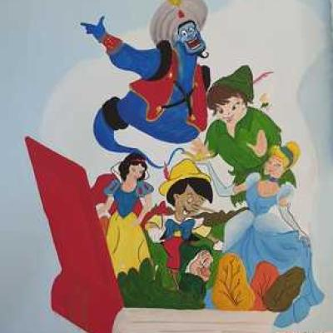
PROJECT●
Active

TALES OF FAR LANDS
Our project will provide the opportunity for nations to introduce their own tales. Tales will be found and students will enter the types of fairy tale heroes. He will introduce the tale and fairy tale hero of his own nation and tell a tale. The tales told by the students will be turned into an e-book and shared with the contacted schools. In addition to providing cultural communication, our project will improve children's language skills. In this way, universal fairy tales will be recognized.

